Fargo Connect Troubleshooting Tips & Debug
Summary
Below are some helpful troubleshooting tips for Fargo Connect and how to set and check debug
Detail
﻿SQLHelperScripts.zip
Fargo Connect uses similar tables as Instant ID so when troubleshooting some steps will be similar.

As far as issues with templates go that end users may have HID is responsible for setting those up and correcting any problems. The end user will need to reach out to HID to work with them directly and you can direct them to submit their issue to: customerservice@hidglobal.com.

When it comes to printing issues where it could be a code problem you will want to set debug via sqlplus(SQLPLUS login), sqldeveloper, or toad.

You set the debug a couple different ways:

A.) You can edit the SetDebugWebCardPrint.sql in the D:\CBORD\DCS\SQL directory to have an additional line
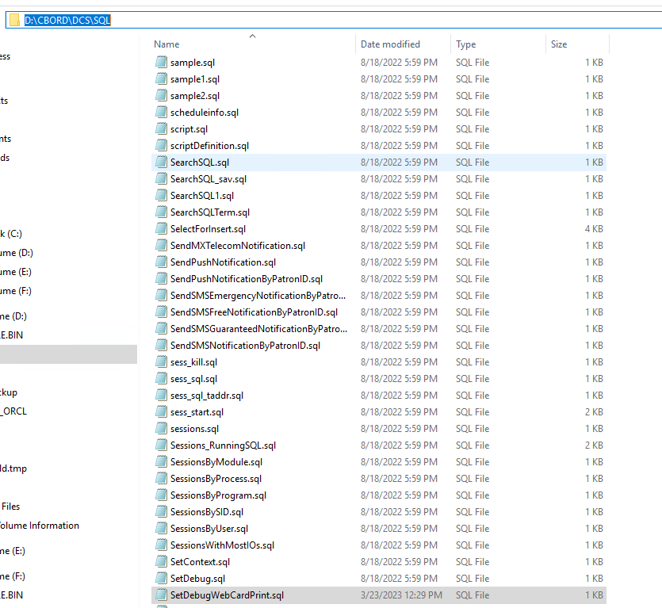
i.) @setdebug HID_Cloud_Print &theDebugLevel and save it make sure to open the file as admin or it will not let you save the file.
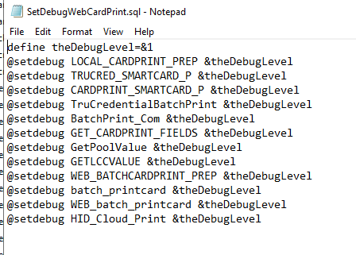

1.) When you run the the sql helper script SetDebugWebCardPrint.sql it will set the debug for all of the modules involved in card printing.
@SetDebugWebCardPrint.sql 7 ( 7 is the debug level). Once it is ran you will see the different modules appear with the debug level.
*********Dont forget to turn this back down after using change debug level to 0, otherwise by default it will turn off after 3 days****************
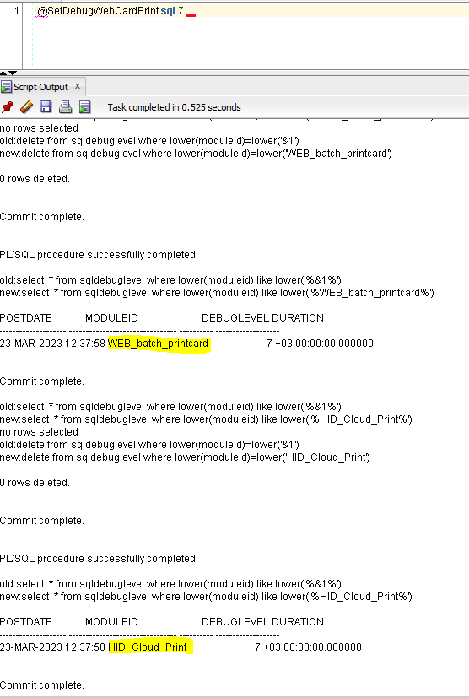

2.) --If not using all module debug script these are individual command examples
*7 represents debug level
**15 represents minutes to stay on
EXEC DCS_OUTPUT.SET_MODULE_DEBUG_LEVEL('CARDPRINT_SMARTCARD_P',7,15);
EXEC DCS_OUTPUT.SET_MODULE_DEBUG_LEVEL('GET_CARDPRINT_FIELDS', 7,15);
EXEC DCS_OUTPUT.SET_MODULE_DEBUG_LEVEL('CARDPRINT_PREP', 7,15);
EXEC DCS_OUTPUT.SET_MODULE_DEBUG_LEVEL('batch_printcard', 7,15);
EXEC DCS_OUTPUT.SET_MODULE_DEBUG_LEVEL('HID_Cloud_Print',7,15);

B.) Queries used to find if there is any data available in the sys log table after a print has been completed ,the results will need to be spooled into a file or copied if Development will need involved:
**You can adjust the look back amount after the sysdate - example to look back a day it would be sysdate - 1***
SELECT * FROM SYSLOG WHERE moduleid = 'GET_COMPOSITE_VALUE' and POSTDATE > SYSDATE - .1 order by postdate;
SELECT * FROM SYSLOG WHERE moduleid = 'CARDPRINT_SMARTCARD_P' and POSTDATE > SYSDATE - .1;
SELECT * FROM SYSLOG WHERE moduleid = 'CARDPRINT_PREP' and POSTDATE > SYSDATE - .1;
SELECT * FROM SYSLOG WHERE moduleid = 'batch_printcard' and POSTDATE > SYSDATE - .1;
SELECT * FROM SYSLOG WHERE moduleid = 'TruCredentialBatchPrint' and POSTDATE > SYSDATE - .1;
SELECT * FROM SYSLOG WHERE moduleid = 'WEB_batch_printcard' and POSTDATE > SYSDATE - .1;
SELECT * FROM SYSLOG WHERE moduleid = 'HID_Cloud_Print' and POSTDATE > SYSDATE - .1;

i.) If you are running the queries from sqlplus in Gold Command prompt you will want to run these two items first so the data appears neater on screen:
@format syslog
alter session set nls_date_format = 'DD-MON-YYYY HH24:MI:SS';
ii.)Modules used for card printing and their definition:
  - GET_CARDPRINT_FIELDS and GET_COMPOSITE_VALUE -In function GET_CARDPRINT_FIELDS. Parses the expressions in WEBCARD_PRINT_FIELDS and returns the respective values.
  - GetPoolValue -In function GETPOOLVALUE. Gets the next value for a particular mediatype when a card is printed.
  - GETLCCVALUE -In function GETLCCVALUE. Gets the next LCC based on the patron and mediatype
  - CARDPRINT_SMARTCARD_P -Parses the values in CREDENTAIL_PROP_MAPPING table
  - TruCredentialBatchPrint -Will show the flow of the web server code. This will provide the most debug
  - batch_printcard -Shows what happens during batch printing
  - WEB_batch_printcard -Also shows batch print flow
  - WEB_BATCHCARDPRINT_PREP -This shows debugging related to some PL/SQL procedures that are invoked when doing batch printing
  - BatchPrint_Com -Shows php function calls to retrieve status of batch print jobs

D.) If the script does not work it means their system doesn't have the SQL Helper scripts and they need to have them transferred onto their system and the Environment variable created.
1.) To create the variable you will go to the start menu and right click then select system

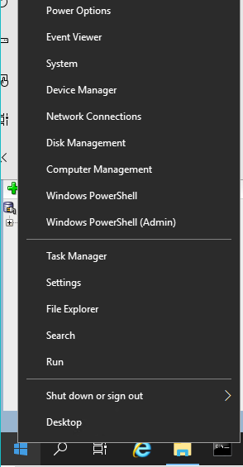
2.) Scroll down till you find System Info and click on it, the system window will pop up and you will select Advanced System Settings and the System Properties menu will appear and you will select Environment Variables. If you do not see SQLPath you will click on New.

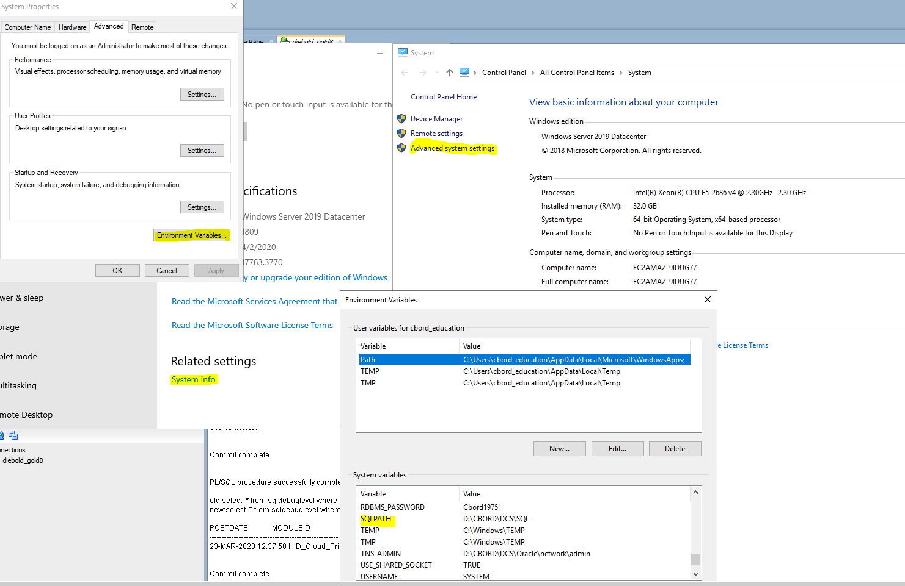
3.) After clicking on new you will enter for the Variable name: SQLPATH and the Value will be the directory you transferred the helper scripts to example: D:\CBORD\DCS\SQL\ click OK
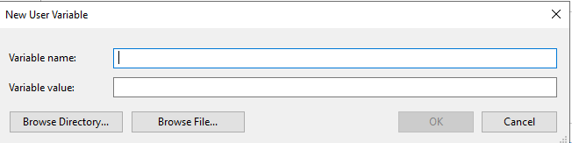
4.) You will need to close out of the sqlplus, sqldeveloper, or toad and log back in to retry the set debug command.
Product Version Numbers - if applicable
Gold 7 & 8
Keywords Fargo Connect Tips Debug Troubleshooting FargoConnect fargo connect fargoconnect
Solution ID
230222111711747
Last Modified Date
03/23/2023 01:10:14 PM
Renew Date
02/22/2025 12:00:00 AM
Created
02/22/2023 11:17:11 AM
Status
Published
Language
English
Collection
CBORD-HORIZON INTERNAL
Author
mam2@cbord.com
Approver
_Gold_KB-Approval+1@cbord.com
Taxonomy
Higher Education > CS Gold > Card Production > HID
Solution Boost
1.0
Views
102
Upland RightAnswers Solution Manager - Version 2024R1

